Title: Secure and Scalable Data Outsourcing in the Public Cloud

Abstract
Data outsourcing is one of the most significant services offered by cloud computing, where end-users buy or lease storage capacity from cloud service providers in a pay-per-use billing model. However, when hosting data into the public cloud, data security and privacy is always the first concern, as few cloud service providers can be fully trusted by end-users. Therefore, enabling secure data outsourcing mechanisms in the public cloud becomes imperative while being challenging. In this talk, I will present our research efforts on guaranteeing the integrity of cloud data with storage auditing service. Our contribution is three-fold. Firstly, a third-party storage auditing mechanism is proposed to ensure that end-users’ data are not corrupted or deleted in the public cloud, while protecting data from being accessed by the third-party auditor. Secondly, the proposed mechanism not only serves for static archived data but also supports scalable and dynamical updates (i.e., block insertion, block modification, block deletion) of cloud data. Thirdly, the proposed mechanism supports batching auditing for multiple users to check the integrity of data stored on multiple cloud servers, which significantly improves the auditing efficiency in large-scale cloud storage systems. In this talk, I will also discuss some research issues on how to control the data access in the public cloud.

Bio
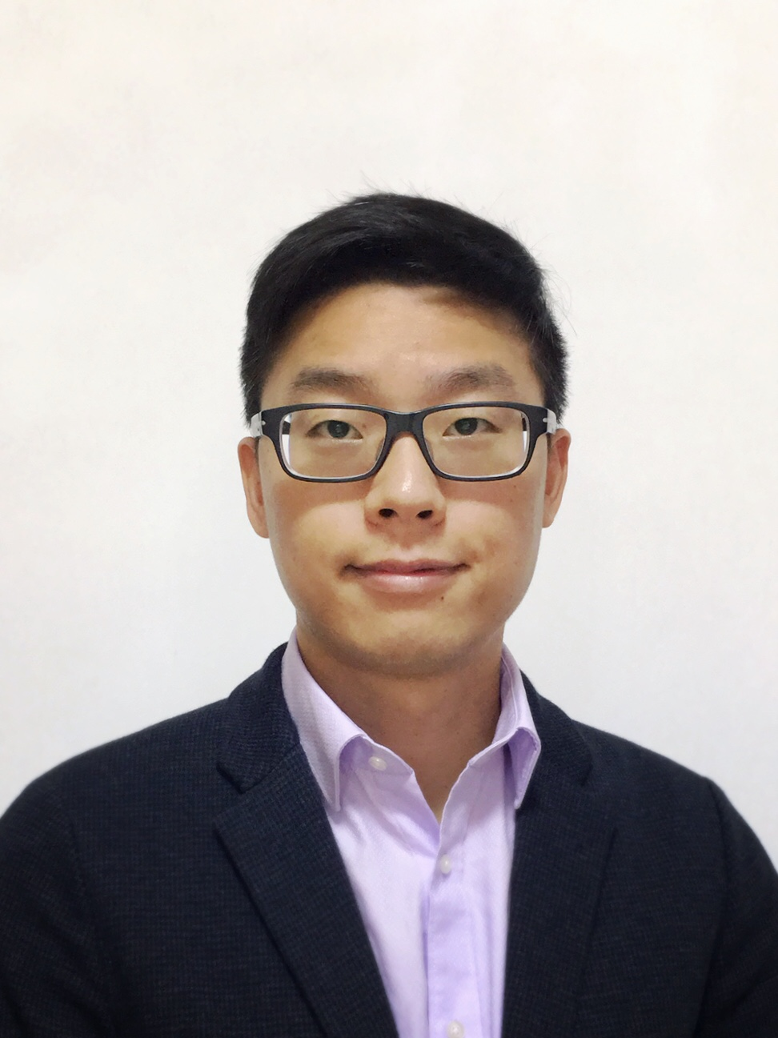
Dr. Kan Yang received his B.Eng. degree in Information Security from University of Science and Technology of China (USTC) in 2008, and his Ph.D. degree in computer science with outstanding research thesis award from City University of Hong Kong in 2013 supervised by Prof. Xiaohua Jia. During his Ph.D. study, he was a visiting student in the Dept. of Computer Science and Engineering at the State University of New York at Buffalo, supervised by Prof. Kui Ren. From Sept. 2013 to July 2014, he was a postdoctoral fellow in the Dept. of Computer Science at the City University of Hong Kong. From July 2014 to June 2016, he was a postdoctoral fellow, the coordinator of security group, at the Broadband Communications Research (BBCR) group in the Dept. of Electrical and Computer Engineering at University of Waterloo, co-supervised by Prof. Xuemin (Sherman) Shen and Prof. Anwar Hasan.

He will join the Department of Computer Science at the University of Memphis as a tenure-track assistant professor in Spring 2017. He is looking for self-motivated Ph.D. students to join his research group. His research interests are in the area of cloud computing, big data, internet of things and distributed systems, with the focus on security and privacy. He has published more than 30 high quality papers that appear in prestigious venues including IEEE TIFS, TPDS, TVT, TMM, TWC, COMMAG, WirelessMag, IEEE INFOCOM’13-15, ICDCS’12, ACM AsciaCCS’13, etc. His research is well recognized, and his publications have received over 900 citations (H-index 13) as of Nov 2016 according to Google Scholar. He has served as the TPC member for many international conferences, e.g., IPCCC’15-16, ICCCN’15-16, AsiaCCS-SCC’14, etc. He is also an active reviewer for many top journals and conferences, such as IEEE JSAC, TPDS, TCOM, TKDE, TIFS, INFOCOM, etc.

