特邀学术报告：From Ubiquitous Connection to Immersive Experience: Research and Experiments on Vehicular Ad Hoc Networks

Abstract: We have witnessed recently the significant progress in research and implementation of Vehicular Ad Hoc Networks (VANETs), which emerges as a promising approach to improve road safety, facilitate vehicle traffic management, and support infotainment applications. In this presentation, we discuss state-of-the-art research and experiments of VANETs carried out at the BBCR Lab, University of Waterloo. First, we highlight some research results including VANETs capacity analysis, content distribution, MAC protocol design, data offloading, heterogeneous networks accessing, and ITS applications. Then, we demonstrate some real world VANETs experiments and implementations conducted in BBCR Lab. Finally, we show our proposed Space-Air-Ground Integrated VANETs architecture. Through cooperating with satellites, HAPs and UAVs to enhance connectivity and extend capacity, the Space-Air-Ground Integrated VANETs are expected to provide ubiquitous connection and immersive experience for vehicle users.

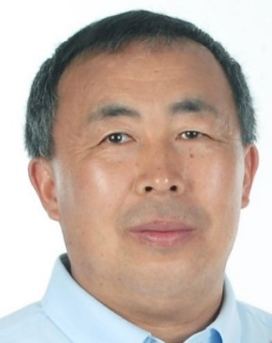
Xuemin Shen教授是滑铁卢大学教授和研究主席，IEEE研究员，加拿大工程研究所、加拿大工程学院、加拿大皇家学会和安大略省专业工程师，IEEE物联网杂志主编。他在中国大连海事大学获得学士学位，在美国罗格斯大学获得硕士和博士学位，在加拿大国家科学与工程研究会（NSERC）担任博士后研究员。
Xuemin Shen教授曾获得加拿大皇家学会的研究员（2015）、IEEE通信学会Ad Hoc和传感器网络技术委员会授予的技术承认奖（2013）、加拿大工程院院士（2012）、加拿大工程学院的研究员（2011）、IEEE Fellow（2009）、滑铁卢大学研究主席（2007-2014）。

特邀学术报告：Cognitive Capability Harvesting (CCH): A Collaborative Network Design

Abstract: Connected things in various cyber-physical systems (CPSs) such as IoTs and smart cities enable us to sense physical environments, extract intelligent information, and better regulate physical systems we heavily depend on in our daily life. This has also generated tremendous traffic burden on our existing telecommunications infrastructure, resulting in significant spectrum shortage. Moreover, it has been witnessed that battery-powered devices such as our smart phones tend to deplete their energy much faster than before and this trend will continue if not carefully considering network-wide power consumption. Furthermore, heterogeneity in network technologies and devices and the lack of comprehensive study on interdependency in a system of systems have also caused serious concerns on security and privacy. How to take a holistic approach to carefully examine network-wide issues on spectrum, energy and security is of paramount importance.

In this talk, the speaker will discuss various related problems and challenges in a connected world and then present a novel collaborative network solution to enabling connected things to effectively harvest in-network capability (spectrum, energy, storage, and computing power) in a cognitive fashion to intelligently manage the spectrum efficiency, energy efficiency, and yes, security!

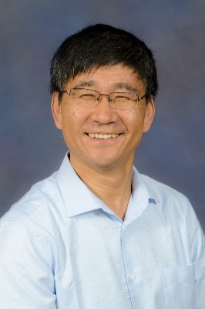
Yuguang (Michael) Fang是佛罗里达大学电子与计算机工程学院的教授。2015年Fang教授因在分布式搜索领域的贡献评选为AAAS Fellow。2008年因在无线网络与移动计算系统领域杰出贡献当选了IEEE Fellow。Fang教授曾获得2015年IEEE Globecom在Symposium on Cognitive Radio and Wireless Networks和Symposium on Communications and Information System Security领域的最佳论文奖。除此之外Fang教授还获得了2015 IEEE Communications & Information Security Technical Committee (CISTC) Technical Recognition Award、2014 IEEE Wireless Communications Technical Committee (WTC) Recognition Award、National Science Foundation Faculty Early Career Development (CAREER) Award 2001、Office of Naval Research Young Investigator Award 2002等众多奖项。
Fang教授从2013年开始一直担任IEEE Transactions on Vehicular Technology期刊的主编，他于2009年-2012年担任过IEEE Wireless Communications期刊的主编。与此同时Fang教授在IEEE Transactions on Mobile Computing、 Wireless Networks (WINET)、IEEE Transactions on Communications、IEEE Transactions on Mobile Computing等的多个期刊担任过编辑。
特邀学术报告：The Deep Learning Vision for Heterogeneous Network Traffic Control: Proposal, Challenges, and Future Perspective

Abstract: Recently, deep learning, an emerging machine learning technique, is garnering a lot of research attention in several computer science areas. However, to the best of our knowledge, its application to improve heterogeneous network traffic control which is an important and challenging area by its own merit has yet to appear because of the difficult challenge in characterizing the appropriate input and output patterns for a deep learning system to correctly reflect the highly dynamic nature of large-scale heterogeneous networks. In this talk, an appropriate input and output characterizations of heterogeneous network traffic will be introduced and a supervised deep neural network system will be proposed. I will describe how our proposed system works and how it differs from traditional neural networks. Also, preliminary results will be discussed and I will demonstrate the encouraging performance of our proposed deep learning system compared to a benchmark routing strategy (Open Shortest Path First (OSPF)) in terms of significantly better signaling overhead, throughput, and delay.

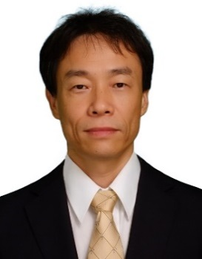
Nei KATO是日本东北大学教授、电气通信研究机构（ROEC）主任，同时还是IEEE 和 IEICE的Fellow。Nei KATO教授从事计算机网络，无线移动通信，卫星通信，ad hoc、传感器和mesh网络方面的研究。曾获得IEEE ICC 2016 Best Paper Award、IEEE IC-NIDC 2014 Best Paper Award、SPECTS 2014 Best Paper Award、IEEE WCNC 2014 Best Paper Award、IEEE GLOBECOM 2014 Best Paper Award、WCSP 2015 Best Paper Award等多项国际会议最佳论文奖。还获得IEEE Communications Society Ad Hoc & Sensor Networks 2016 Outstanding Service & Leadership Recognition Award、IEICE Technical Committee on Satellite Communication, Research Award、IEEE Fellow Award of the IEEE Communication Society、IEICE Outstanding Contribution Award等众多国际奖项。此外，他还担任IEEE通信学会董事会成员，IEEE通信协会仙台分会主席和IEEE通信学会奖委员会（2015-2017）主席，IEEE网络杂志主编（2015.7-），IEEE物联网期刊副主编（2013-）和IEEE汽车技术交易区域编辑（2014-），IEICE卫星通信技术委员会主席（2011-2012）， IEEE计算机学会研究委员会副主席（2016年）。

特邀学术报告：New Paradigm in Energy Harvesting Wireless Communication

Abstract: Energy harvesting from the environment provides solutions for several critical challenges in building future ICT systems: reduce utility bills, control carbon pollution, and enable everlasting power supplies in IoT applications. In this talk, we first review the recent developments in the field of energy harvesting wireless communication, followed by a specific case study over an energy harvesting ad hoc network. We then focus on the discussions of several promising directions in this new paradigm: the exploration of energy diversity, the concept of power access vs. spectrum access, and the system vs. network vs. link multilevel information and energy resource matching.

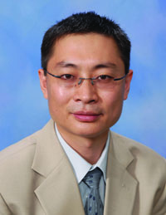
Shuguang(Robert) Cui是美国德克萨斯A&M大学电子与计算机工程学院教授。Cui教授于1997年在北京邮电大学得学士学位（系第一名），2000年在加拿大McMaster大学获得硕士学位，2005年在美国斯坦福大学获得博士学位。并于2013年至2014年在上海科技大学担任访问教授。
Cui教授的科研方向主要集中在：面向大数据的网络信息处理，认知无线电系统的优化和设计，无线传感器网络和物联网的能耗优化，估计与检测系统的跨层设计，基于可再生能源的通信系统优化设计。已在国际一流期刊和会议上发表了过百篇论文，其中有八篇期刊文章自发表之日至今被引用次数在同期刊中排名前十（其中一篇引用次数排名第一，三篇引用次数排名第二)。Cui教授是IEEE信号处理协会2012年最佳论文奖获得者, 并曾担任多个国际期刊的编委(IEEE TSP, TWC, TVT, CL)，是IEEE通信协会无线技术委员会(WTC)的秘书长，IEEE信号处理协会SPCOM技术委员会的委员，并担任其工业／政府关系子委员会的主席。Cui教授在2013年当选IEEE Fellow（博士毕业后8年内当选为IEEE历史上最快之一），并在2014年被任命为IEEE Transactions on Big Data的Steering Committee委员，负责第一届主编的选定。

特邀学术报告：A Hyper Cellular Architecture for 5G and Beyond

Abstract: Cellular concept was invented to improve the spectrum efficiency by spectrum reuse and has contributed a lot for the explosive deployment of today’s mobile communication industry. As mobile data and video traffic is fast growing, the next-generation mobile communication (5G) networks and beyond are expected to further provide 10-fold more capacity than 4G mobile networks with the limited spectrum as well as energy resources. To deal with this challenge, the traditional physical- and MAC-layer capacity-enhancement approaches are no more sufficient and efficient. A system- or network-level approach is needed, including rethinking about the existing cellular structure. On the other hand, cellular networks are transforming from just a mobile communication platform to a smart information infrastructure on which more and more always-online type of traffic (e.g., short but frequent signaling packets of various social networks, sensing information of smart earth and smart community, control packets in cooperative heterogeneous wireless networks) need to be handled in an energy-efficient way. As a result, the existing cellular framework should be revisited.

In this talk, we propose a new cellular framework, named hyper-cellular architecture (HCA), aiming at increasing the whole network capacity by more than 10-fold based on the existing limited spectrum and energy resources as well as accommodating ever-increasing always-online traffic in a more energy-efficient way. The key idea here is to separate the coverage of control signals from the coverage of data signals so that the data coverage can be more elastic in accordance with the dynamics of traffic needs and QoS requirements. This can be considered as the further extension of the existing C-RAN concept and one of the key candidate technologies for 5G mobile communications systems and beyond. Some preliminary results have shown that this new paradigm has a great potential in the capacity enhancement and energy savings. Its software-defined implementation through the convergence of virtual BS and edge cloud technologies will also be discussed.

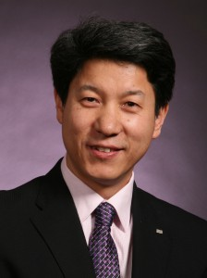
牛志升是清华大学信息科学与技术学院副院长、电子工程学系教授。同时，目前，他也是IEICE的fellow和理事会成员，IEEE通信学会会议出版主任，IEEE 10区会议和技术研讨会协调员，中国电子学会理事会成员，中国学会信息与传播网络委员会副主席。2012年牛教授当选IEEE的Fellow。
牛教授自2007以来一直研究绿色通信，并在该领域广泛发表。他一直担任IEEE无线通信杂志“绿色无线电通信和网络特刊”和“绿色通信网络特刊”的客座联合编辑。他现为中国“Fundamental Research on the Energy and Resource Optimized Hyper-Cellular Mobile Communication System”（2012-2016）国家基础研究计划（973项目）的首席科学家。牛教授曾获得Asia-Pacific Conference on Communication （2007,2009）、IEEE International Conference on Communication Technologies (ICCT2011)等最佳论文奖。Award for Electronic Sci. & Tech. Advancement, Chinese Institute of Electronics，Distinguished Young Scholar Award, Nature Science Foundation of China，Outstanding Contribution to IEEE Standard 1888-2011, IEEE Standard Association，Distinguished Lecture, IEEE Communication Society等国内外奖项。

特邀学术报告：Encrypted Search and Privacy-Preserving Task Recommendation in Crowdsourcing

Abstract: As the growing concern of data security and privacy, people would choose to encrypt their data before outsourcing them to the cloud. Information search over encrypted data becomes a challenging task. In this talk, we will first introduce the problems and challenges of search over encrypted data. Then, we will discuss a typical application of encrypted search: a privacy-preserved task recommendation scheme for crowdsourcing platforms. In such a platform, there are many task requesters that submit the tasks they wish to be outsourced to the crowds with task specification and requirements; and there are large number of workers that wish to subscribe the tasks with their interests and qualifications. The key challenge is that the task requesters do not want the server (crowdsourcing platform) to know any information about their tasks, and the workers do not want to reveal any of their personal information, interests and qualifications, to the server. The server will be able to recommend outsourced tasks to the suitable workers based on the encrypted data of the tasks and the workers.

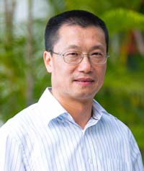
Xiaohua Jia教授是香港城市大学计算机科学学院的教授，同时还是Computer Society的IEEE Fellow。他于1984年和1987年分别获得中国科技大学的学士和硕士学位，于1991年在东京大学获得了博士学位。Jia教授主要研究无线网络、传感器网络、分布式系统、云计算和互联网技术。Jia教授担任了 IEEE Trans. On Parallel and Distributed Systems（2006-2009）、Wireless Networks、Journal of World Wide Web和Journal of Combinatorial Optimization等期刊的编辑。除此之外Jia教授还担任过ACM MobiHoc 2008,、TPC Co-Chair of IEEE MASS 2009、International Vice-Chair of INFOCOM 2005、TPC Area-Chair of INFOCOM 2010以及TPC Co-Chair of GLOBECOM 2010 - Ad-hoc and Sensor Networking Symposium等会议的大会主席。

特邀学术报告：Joint Admission, Channel Assignment, and Scheduling of Communication Requests in Multi-Channel Wireless Networks

Abstract: Consider a set of point-to-point communication requests in a multi-channel multihop wireless network. Each request is associated with a traffic demand of at most one unit of transmission time, and a weight representing the utility that can be accrued if its demand is fully met. A subset of requests is said to be feasible if they can be scheduled within one unit of time without spectral splitting. The problem Maximum-Weighted Feasible Set (MWFS) seeks a feasible subset with maximum total weight together with a channel assignment and transmission schedule of them whose length is at most one unit of time. This talk presents efficient and provably good approximation algorithms for the problem MWFS.

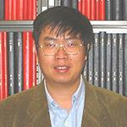
Pengjun Wan教授是伊利诺伊理工学院的教授，他于1986 - 1990年在清华大学应用数学系获得学士学位，于1990 - 1993年在中国科学院应用数学研究所获得硕士学位，于1993 – 1997在明尼苏达大学计算机与信息科学系获得博士学位。 Pengjun Wan教授是IEEE / ACM网络交易，计算机与系统科学学报的副主编。另外，Pengjun Wan教授是The Thirty-Fifth Annual IEEE International Conference on Computer Communications (INFOCOM), 2016、The Ninth ACM International Symposium on Mobile Ad Hoc Networking and Computing (MOBIHOC), 2008、The Fourth International Conference on Mobile Ad-hoc and Sensor Networks (MSN), 2008等会议的主席/联合主席。同时还是The ASI (Advanced Study Institute) Workshop on Wireless Sensor Networks, 2006.The NSF Workshop on Theoretical Aspects of Wireless Ad Hoc, Sensor, and Peer-to-Peer Networks, 2004.The NSF/DIMACS Workshop on Optical Networks, 1998.研讨会的联合主办人。Pengjun Wan教授从2009年至今是WASA指导委员会协调员，2010年担任了MSN指导委员会协调员。

特邀学术报告：Integrating Social Links into Vehicular Ad Hoc Networks (VANETs): Social-aware, Secure and Privacy-Preserving Data Forwarding in VANETs

Abstract: Vehicular communication technologies have been envisioned as a promising approach for improving road safety, enhancing driving experience, and improving traffic management. In the future, cars on our roads will be equipped with vehicle-to-vehicle (V2V) communication technology enabling them to communicate with each other and forming a large self-organized ad hoc network. These networks are called vehicular ad hoc network (VANET). In this talk, we first identify some security and privacy challenges in VANETs. Then, we look into how to integrate social links into VANETs. Specifically, we study social behavior and interaction in VANETs and then propose a social-aware, secure and privacy-preserving packet forwarding scheme. With the proposed scheme, Roadside Units (RSUs) deployed along the roadside can assist in packet forwarding to achieve highly reliable transmissions, which is considered critical for many vehicle applications. In specific, we heuristically define how to evaluate each traffic intersection’s social degree in a VANET. Based on the social degree information, we then strategically place RSUs at some high-social intersections. As a result, these RSUs can provide tremendous assistance in temporarily storing packets and helping packet forwarding in order to achieve high delivery ratio in a cost-efficient way. Furthermore, these RSUs can form a mix network to shuffle messages transmitted over vehicular network. As a result, security and privacy of vehicular communications can be guaranteed.

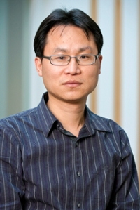
Xiaodong Lin是加拿大安省理工大学副教授，IEEE Fellow。他获得过滑铁卢大学电气与计算机工程博士学位，北京邮电大学信息工程博士学位。Lin教授的研究领域包括：计算机和网络安全，特别是在无线网络安全，应用加密，计算机取证和软件安全领域。Lin教授曾在国际会议上多次获得最佳论文奖，包括第18届国际计算机通信和网络会议（ICCCN 2009），第五届身体区域网络国际会议（BodyNets 2010）和IEEE国际通信会议（ICC 2007）。林博士是NSERC加拿大研究生奖学金（CGS）博士学位的获得者，并被选为NSERC博士学位奖（工程和计算机科学类）的大学提名人。

