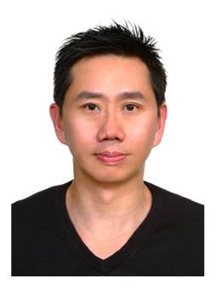
报告题目: Signaling Reduction and Energy Saving of Small-Cell Networks

报 告 人 : Prof. Phone Lin
National Taiwan University (NTU), Taiwan
邀 请 人 ：喻 莉 教授
华中科技大学电子信息与通信学院

报告时间: 2017年5月16日（星期二），上午9点30

报告地点: 武汉光电国家实验室A302

Abstract:

The small cell technology coexisting with the outdoor macro cell has been widely adopted in heterogeneous radio access network (Het-RAN) to provide transmission service with higher data rate. In LTE Het-RAN, small cell (HeNB) provides higher data transmission service, offloads traffic from a macro cell (eNB), and extends the service area of a macro cell. Typically, a small cell has radio coverage of 5-10 meter-radius. A macro cell with radio coverage of 0.5-2 kilometer-radius may overlap with large amount of small cells. Small cell may adopt the same or different radio access technologies (RATs) and the same or different tracking area (TA) of a macro cell. Importantly, the service area of small cells may be discontinued. In LTE Het-RAN, the characteristic of small cells (i.e., the service area may be discontinued) can be treated as “islands” that do not overlap with each other. In this talk, I will focus on two important issues in Het-RAN, including (1) Signaling Reduction; (2) Energy Saving.

Biography:

Phone Lin is a Professor at National Taiwan University (NTU), Taiwan, holding professorship in the Department of Computer Science and Information Engineering, Graduate Institute of Networking and Multimedia, Telecommunications Research Center of College of EECS, and Graduate Institute of Medical Device and Imaging, Collage of Medicine.

Lin serves on the editorial boards of IEEE Trans. on Vehicular Technology, IEEE Wireless Communications Magazine, IEEE Network Magazine, IEEE Internet of Things Journal, etc. He has also been involved in several prestigious conferences.

Dr. Lin’s current research interests include “Fog Networks,” “Machine to Machine (M2M)/Internet of Things (IoT),” “Software Defined Networks (SDN),” “Smart Data Pricing,” “Relation, Privacy, Security of Social Networks,” “Decision Process” and “Performance Modeling.” Lin has received many prestigious technical research/service awards, such as The Outstanding Research Award, Minstry of Science and Technology, Taiwan in 2016, The Best Young Researcher of IEEE ComSoc Asia-Pacific Young Researcher Award in 2007, The Distinguished Electrical Engineering Professor Award of the Chinese Institute of Electrical Engineering in 2012, Ten Outstanding Young Persons Award of Taiwan (Science & Technology) in 2009. Phone Lin is a Fellow of IEEE.

